Twenty Ninth Sunday in Ordinary Time
Saturday /Sunday - 16th/ 17th October 2021

We are celebrating the 28th Sunday in Ordinary Time

Our following of Christ is motivated by the faith that he alone can grant us eternal life. To obtain eternal life that Jesus offers we need to be ready to share in the passion of Christ. Our discipleship implies our readiness to accept whatever Jesus has gone through in his life. To be so closely united to Jesus would mean possessing Christ-like attitudes and values. It means voluntarily walking the way of the cross with unquestioning, unwavering faith and unconditional commitment.

Continuing our series on extracts from sermons by Pope Francis.

“If we think about it, we grow not so much on the basis of our successes and the things we have, but above all in difficult and fragile moments. There, in our need, we mature; there we open our hearts to God, to others, to the meaning of life. When we feel small in the face of a problem, small in front of a cross, an illness, when we experience fatigue and loneliness, let us not get discouraged, because with God weakness is not an obstacle but an opportunity”

IN MEMORIAM

We remember those for whom this Weekend Masses are offered:
Saturday 4th 7:00pm - Irene McNamara RIP (A)
Elizabeth Belton RIP (A)
Sunday 5th 10:00am - Ger Ryan RIP
Daniel Murray RIP (A)
Timothy O’Connor RIP (A)
11:30am - Noel Clohessy RIP (A)
Evan Clohessy RIP (A)

The Mass intentions for the coming week:
Tuesday 19th – St Paul of the Cross 9:45am: Rosemary Ireton RIP (A)

Wednesday 20th – of the day 9:45am: Ger Ryan RIP
Nancy Henchy RIP

Thursday 21st – of the day 9:45am: Peggy & Paddy Hayes

Friday 22nd – St John Paul II 9:45am: Denis Cronin RIP (A)

Saturday 23rd – 30th Sunday 7:00pm: Catherine Ross’s Intentions

Sunday 24th– 24th Sunday - Mission Sunday 10.00am:
11:30am: Bernard Hanly RIP (A)

Note: All Masses are available online via church services
NOTICES
- The Irish Catholic
Please support The Irish Catholic newspaper which is available at the back of the church at a cost of €2.50

- Eucharistic Adoration
In this parish we have the privilege of Eucharistic Adoration every day – on Tuesday from 10am until 10pm and on the other six days from 6pm until 10pm. This is a wonderful devotion from which flows transforming graces for those who take part and for our whole parish. All are welcome and indeed we earnestly encourage your participation.

PRAYER WHILE VISITING THE MOST BLESSED SACRAMENT
My Lord Jesus Christ, for the love which You bear to men, you remain night and day in this Sacrament full of compassion and of love, awaiting, calling, and welcoming all who come to visit You. I believe that You are present in the Sacrament of the Altar: I adore You from the abyss of my nothingness, and I thank You for all the graces which You have bestowed upon me and in particular for having given me Yourself in this Sacrament, for having given me your holy Mother Mary for my advocate, and for having called me to visit You in this chapel. I now salute
Your most loving Heart: and this for three ends:
1. In thanksgiving for this great gift;
2. To make amends to You for all the outrages which You receive in this Sacrament from all Your enemies;
3. I intend by this visit to adore You in all the places on earth in which You are the least revered and the most abandoned.
- by St Alphonsus Ligouri
Message for Limerick Legion of Mary from Bishop Brendan Leahy
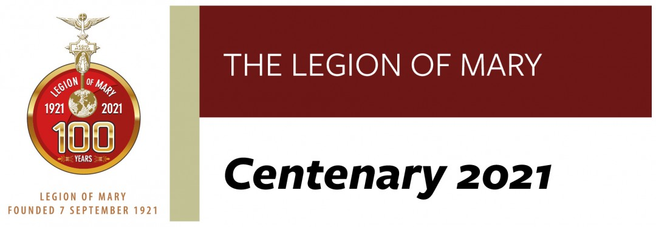
Let us pray that the inspiring spark of charity that filled the heart of Frank Duff and the early generations of the Legion will ignite anew here in Limerick for the good of the Church and society. Once again, I thank you for your commitment and perseverance. May God in his mercy grant you many graces. Every blessing,

The full text of Bishop Leahy’s message is available here

Month of the Holy Rosary

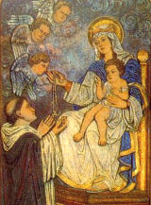
The Lord hath blessed thee by His power, because by thee He hath brought our enemies to nought.
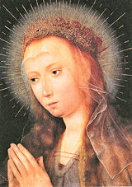
Fear not, Mary, thou hast found grace with the Lord; behold, thou shalt conceive and bring forth a son, alleluia.
The month of October is dedicated to the Holy Rosary. According to an account by fifteenth-century Dominican, Alan de la Roch, Mary appeared to St. Dominic in 1206 after he had been praying and doing severe penances because of his lack of success in combating the Albigensian heresy. Mary praised him for his valiant fight against the heretics and then gave him the Rosary as a mighty weapon, explained its uses and efficacy, and told him to preach it to others.
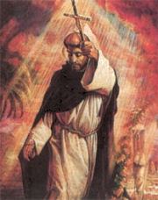
"Since the prayers of the Rosary come from such excellent sources — from Our Lord Himself, from inspired Scripture, and from the Church — it is not surprising that the Rosary is so dear to our Blessed Mother and so powerful with heaven.
"If we consider the power of the Rosary as seen in its effects, we find a great abundance of proofs of its wonderful value. Many are the favors granted to private individuals through its devout recitation: there are few devoted users of the Rosary who cannot testify to experiencing its power in their own lives. If we turn to history, we see many great triumphs of the Rosary. Early tradition attributes the defeat of the Albigensians at the Battle of Muret in 1213 to the Rosary. But even those who do not accept this tradition will admit that St. Pius V attributed the great defeat of the Turkish fleet on the first Sunday of October, 1571, to the fact that at the same time the Rosary confraternities at Rome and elsewhere were holding their processions. Accordingly, he ordered a commemoration of the Rosary to be made on that day. Two years later, Gregory XIII allowed the celebration of a feast of the Rosary in churches having an altar dedicated to the Rosary. In 1671, Clement X extended the feast to all Spain. A second great victory over the Turks, who once, like the Russians, threatened the ruin of Christian civilization, occurred on August 5, 1716, when Prince Eugene defeated them at Peterwardein in Hungary. Thereupon Clement XI extended the feast of the Rosary to the whole Church.
"Today, when dangers far greater than those of the ancient Turks threaten not only Christianity but all civilization, we are urged by our Blessed Mother to turn again to the Rosary for help. If men in sufficient numbers do this, and at the same time carry out the other conditions that she has laid down, we have the greater reason for confidence that we will be delivered from our dangers." -- Mary in our Life by Fr. William G. Most
The Rosary and the Liturgical Year
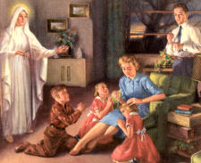
The Rosary had its origin in the liturgical mentality of former ages. Even at the present time it is called "Mary's Psalter." There still are Catholics who consider the 150 Hail Marys a substitute for the 150 psalms for those persons who neither have the time, the education, nor the opportunity to pray the Hours of the Divine Office. Thus "Mary's Psalter" is a shortened, simplified "breviary" — alongside the common Hour-prayer of the Church. — The Church's Year of Grace, Dr. Pius Parsch
The Rosary is Christocentric setting forth the entire life of Jesus Christ, the passion, death, resurrection and glory. Of course, the Rosary honors and contemplates Mary too, and rightly so, for the same reason that the Liturgical Year does likewise: "Because of the mission she received from God, her life is most closely linked with the mysteries of Jesus Christ, and there is no one who has followed in the footsteps of the Incarnate Word more closely and with more merit than she"142 (Mediator Dei). Meditation on this cycle of Joyful, Sorrowful, Glorious and Luminous Mysteries makes the Rosary not only "a breviary or summary of the Gospel and of Christian life,"(Ingravescentibus malis) but also a compendium of the Liturgical Year. Therewith the Rosary stands revealed as a dynamic teacher and nurturer of Christian faith, morality, and spiritual perfection, fostering in various ways faith, hope, charity, and the other virtues, and mediating special graces, all to the end that we may become more and more like unto Christ. — Mariology, Juniper B. Carol, O.F.M.
The Rosary and the Popes
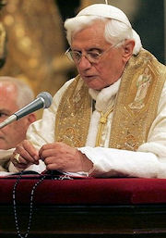
No form of extra-liturgical devotion to Mary is more widely practiced among the faithful or found by them to be more satisfyingly complete than the Rosary, which has come to be regarded as the very badge of Catholic piety. No form of extra-liturgical devotion to Mary has been recommended more warmly or frequently by the Popes. With perhaps two exceptions, all the Sovereign Pontiffs from Sixtus IV in 1478 down to John XXIII, especially Leo XIII (in 23 documents, ten of them encyclicals entirely on the Rosary) and his successors, have extolled this form of prayer, which has been the favorite, moreover, of such saints as Teresa of Avila, Francis de Sales, Louis de Montfort, Alphonsus Liguori, Don Bosco, Bernadette, and many more.
The authentic Rosary is a happy combination of vocal and mental prayer, each of which is essential to the devotion. It is incorrect to say that meditation is "the very essence of the Rosary devotion," for vocal recitation of the prayers is also of the essence. Meditation is, of course, the nobler element, the "soul," while vocal prayer is the "body" of the devotion. The Rosary, Pope Leo XIII declared, "is composed of two parts, distinct but inseparable — the meditation on the mysteries and the recitation of the prayers. It is thus a kind of prayer that requires not only some raising of the soul to God, but also a particular and explicit attention" (Incunda semper). Hence, as Pope Pius XI stated, they err "who consider this devotion merely a boresome formula repeated with monotonous and singsong intonation" (Ingravescentibus malis). Moreover, as Pius XI put it, "both piety and love, although always breathing forth the same words, do not, however, repeat the same thing, but they fervently express something ever new which the loving heart always sends forth." And finally, in the words of Pius XII, "the recitation of identical formulas, repeated so many times, rather than rendering the prayer sterile and boring, has on the contrary the admirable quality of infusing confidence in him who prays, and brings to bear a gentle compulsion on the motherly heart of Mary (Ingravescentibus malis). — Mariology, Juniper B. Carol, O.F.M.
Pope Benedict XVI in an address at the Basilica of St. Mary Major where he prayed the rosary with the faithful said:
Today, together we confirm that the Holy Rosary is not a pious practice banished to the past, like prayers of other times thought of with nostalgia. Instead, the Rosary is experiencing a new Springtime. Without a doubt, this is one of the most eloquent signs of love that the young generation nourish for Jesus and his Mother, Mary. In the current world, so dispersive, this prayer helps to put Christ at the centre, as the Virgin did, who meditated within all that was said about her Son, and also what he did and said. When reciting the Rosary, the important and meaningful moments of salvation history are relived. The various steps of Christ's mission are traced. With Mary the heart is oriented toward the mystery of Jesus. Christ is put at the centre of our life, of our time, of our city, through the contemplation and meditation of his holy mysteries of joy, light, sorrow and glory. May Mary help us to welcome within ourselves the grace emanating from these mysteries, so that through us we can "water" society, beginning with our daily relationships, and purifying them from so many negative forces, thus opening them to the newness of God. The Rosary, when it is prayed in an authentic way, not mechanical and superficial but profoundly, it brings, in fact, peace and reconciliation. It contains within itself the healing power of the Most Holy Name of Jesus, invoked with faith and love at the centre of each "Hail Mary".
The Mysteries of the Rosary
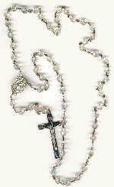
Until about the 15th century hundreds of mysteries were part of the Rosary devotion then the 15 mysteries that we know today were definitively fixed as "the Mysteries of the Rosary." Pope John Paul II, in his encyclical, Rosarium Virginis Mariae, in 2002 added the five Luminous Mysteries.
Through the meditations of the complete Rosary one recalls and has impressed on his mind, the Popes tell us, "the chief mysteries of the Christian religion," "the mysteries of our Redemption," "the great mysteries of Jesus and His Mother united in joys, sorrows, and triumphs." The twenty mysteries are divided into four equal groups, known as "The Joyful," "The Sorrowful," "The Glorious," and "The Luminous Mysteries."
Pope Francis Proclaims Year of St Joseph

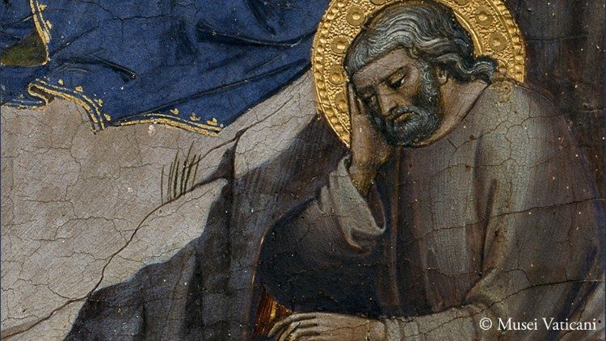
Pope Francis recalls the 150th anniversary of the declaration of Saint Joseph as Patron of the Universal Church. To mark the occasion, the Holy Father has proclaimed a “Year of Saint Joseph” from 8 December 2020 to 8 December 2021.

A Celtic Journey with St Joseph – Contemplating His Life with Harp, Voice and Strings:
Music by Vox Hiberniae – a group of musicians that serve as organists, directors of music, cantors and instrumentalists across parishes in the Dublin Archdiocese. To view please click on this link
For details of the decree issued with regard to a plenary indulgence for the year of St Joseph please click on this link

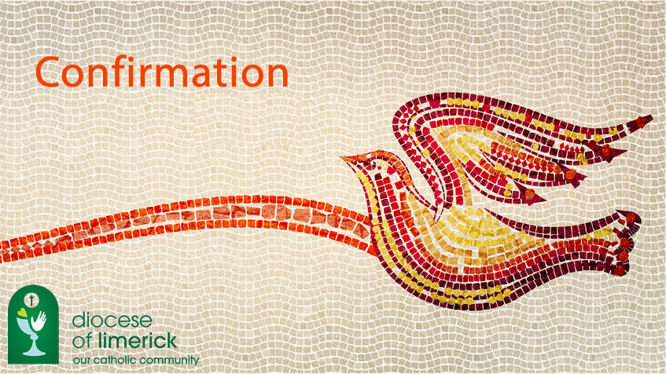

- Confirmation 2021
During the coming week we conclude the Confirmation ceremonies for the young men and women of our Parish. We pray for those preparing to receive Confirmation and congratulate all those have received the sacrament over the past number of weeks. We pray God’s blessing on all.

